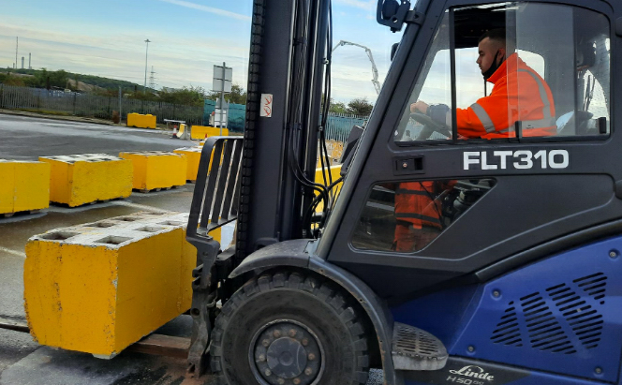
Day in the Life…
Lewis Nicholson
Safety, Health & Environmental
Technician Apprentice, C. RO Ports, Killingholme

Joined C. Ro Ports: 4th January 2021
Age at start: 24
Title: H&S Technician Apprentice

Tell us about yourself, what do you do?
My name is Lewis Nicholson, I’m 12 months into my 18 month Level 3 H&S Apprenticeship at C.RO Ports Killingholme, training with RHG Consulting Ltd.

I work day to day within the Health & Safety Department which consists of one Health & Safety Officer and one UK Health, Safety and Compliance Manager, both of which I have formed a well-working relationship with.

Tell us about a typical day here at C. Ro Ports in your job role
Every day is different working at C.RO Ports and there is plenty of tasks to be getting on with. Since starting here, I have acquired numerous tasks that consist of the following;
Spotlight box checks – These are red deposit boxes that are situated across the entire site within different areas, so that staff or visitors can record near misses/safety concerns on our spotlight forms and then post them for the Health & Safety Department to collect. I check the boxes once or twice per week and have done since I joined the company.
Fire alarm check at the Visitors Centre – Every Friday afternoon I walk across to the Visitors Centre to check the fire alarm and record my checks within the fire logbook.
Emergency lights & fire extinguisher checks – Once a month I carry out emergency lighting checks to ensure all lights are working, as well as checking all fire extinguishers to ensure gauges are within correct pressure levels on foam and water extinguishers and ensure they haven’t been tampered with or used. I record my findings and keep them documented within our matrix log.
First aid checks – This consists of ensuring all first aid kits are fully stocked up and all items within them are in date.
As well as carrying out my weekly/monthly routine checks, depending on what is happening on the port, I may be carrying out investigations in regards to accidents/incidents. I have completed a 3-day Accident Investigation course, which forms part of my apprenticeship. After completing the course, it gave me more of an understanding of focusing on in terms of finding out root causes and implementing the ‘5 whys’ in order to achieve the right possible outcomes.
I carry out area inspections within different departments to identify anything that may lead to issues or problems that requires addressing to the departmental supervisors/managers. Another task carried out by the Health and Safety Department are compliance checks, which consists of selecting a risk assessment/safe systems of work (RASSOW), then carrying out an audit on the task, to ensure staff are complying with the RASSOW.
I have also had the opportunity of completing a 4-day fork lift training course, provided by C.RO Ports, allowing me to utilize my new skillset to create a safe walkway using yellow concrete blocks. Although I carried out this task, it was originally a recommendation for the repairs department to complete. I completed this task myself, as it allowed me to use my forklift skillset as a piece for my Apprenticeship Portfolio.
